Towards Reproducible AI-Generated Scientific Visualizations:
A Seed-Structure Mapping Approach for Structured Output Optimization in Diffusion-Based Models
Diana Ticudean
Technical University of Cluj-Napoca, Faculty of Industrial Engineering, Robotics and Management of Production
diana.ticudean@yahoo.com
ORCID: https://orcid.org/0009-0007-1603-2436

Abstract
Diffusion-based image generation models produce non-deterministic structured outputs when prompted to generate scientific visualizations such as charts, network diagrams, and flowcharts, requiring extensive manual retouching before the outputs are suitable for use. This paper investigates whether the relationship between the initial noise seed and the structural fidelity of the generated output is learnable, and whether a predictive seed-structure mapping can improve first-pass generation accuracy without modifying model weights. I generate a labeled dataset of 50,000 seed-prompt-fidelity triples across five structured output types using Stable Diffusion 1.5, train a lightweight XGBoost mapping model on this dataset, and evaluate a seed pre-selection strategy against a random baseline on held-out test prompts. I demonstrate that seed pre-selection improves aggregate first-pass acceptance rate from 21.7% under random selection to 64.0%, an absolute gain of 42.3 percentage points. Feature importance analysis reveals that output type accounts for 94.2% of the model's predictive weight, establishing that structural achievability is primarily type-determined rather than seed-determined within SD 1.5. The methodology is presented as a general framework for structured-output-aware generation applicable above existing models without architectural modification.

1. Introduction
Artificial intelligence image generation has matured rapidly over the past several years, with diffusion-based models now capable of producing photorealistic imagery from natural language prompts with remarkable fidelity. Researchers and practitioners have begun applying these tools beyond artistic generation to scientific visualization tasks - producing charts, network diagrams, flowcharts, and data plots intended for use in academic publications, technical reports, and research presentations. In these contexts, visual accuracy is not merely aesthetic but functionally critical. A bar chart with incorrect proportions, a network diagram with wrong topology, or a scatter plot with misplaced data points can directly mislead scientific conclusions, introduce errors into peer-reviewed work, or undermine the reproducibility of published findings. As AI-assisted visualization becomes more widespread, the gap between what these models can produce visually and what they must produce structurally becomes an increasingly consequential problem.
The fundamental difficulty is that current generative models approach structured visual outputs the same way they approach artistic images: as a sampling problem over a learned distribution of visual appearances. These models are trained predominantly on photographic and artistic data, not on data-faithful diagrams, which means they have no internal representation of what it means for a chart to be numerically correct or for a diagram to accurately reflect a defined structure. The generation process begins from a randomly sampled noise tensor, and the entire diffusion trajectory from that noise to the final image is governed by the initial seed. Since seeds are selected without any knowledge of their structural consequences, the model samples blindly from the full noise space - the vast majority of which does not lead to data-faithful visualizations, regardless of how precisely the prompt is written.
This blind sampling produces the familiar generate-evaluate-retouch cycle: a user prompts the model, evaluates the output for structural correctness, and manually corrects errors before the figure is suitable for use. For simple charts this may require only minor adjustments, but for complex structured outputs, multi-series plots, hierarchical diagrams, network topologies, multiple generation attempts and significant manual retouching effort are typically required. This cycle directly undermines the efficiency benefits of AI-assisted visualization and introduces a bottleneck that scales poorly with output complexity. More fundamentally, it shifts the burden of structural correctness back onto the human user, defeating the purpose of automated generation.
The key insight motivating this work is that the noise seed is not a source of true randomness, it is a deterministic input to a deterministic algorithm. A fixed model given a fixed seed will always produce the same output. This observation was formalized in a prior technical note (Ticudean, 2026) [1], which demonstrated that pseudo-random number generators, despite their stochastic appearance, are entirely predictable once their algorithm and seed are known. The PRNG trap documented there, where two systems using different algorithms produced completely divergent outputs from the same seed integer, illustrates precisely how uncharacterized seed behavior leads to uncontrolled and irreproducible outcomes. The same principle applies here: the apparent non-determinism of diffusion model outputs is not a property of the generation process itself, but a consequence of selecting seeds without knowledge of their structural implications. The randomness is not real - it is simply uncharacterized.
I extend this insight to the structured generation domain. If seeds deterministically govern generation trajectories, and if some trajectories lead to structurally faithful outputs while others do not, then characterizing which seeds lead to which outcomes is both possible and actionable. Rather than sampling blindly, a model equipped with a seed-structure map can pre-select seeds likely to produce accurate visualizations before any generation occurs, collapsing the generate-evaluate-retouch cycle into a single, reliable first-pass generation step. This reframes the structured generation problem from one of chance to one of informed selection.
This paper makes the following contributions. First, I establish empirically that a consistent seed-fidelity relationship exists within a fixed diffusion model architecture, showing that certain seeds reliably steer generation toward structurally faithful outputs across prompt types. Second, I propose a lightweight seed-structure mapping model capable of predicting output fidelity from seed and prompt type alone, without generating the image. Third, I demonstrate that seed pre-selection using this map significantly improves first-pass structural accuracy relative to random seed selection, reducing the need for manual retouching. Fourth, I provide a general methodology transferable to other model architectures and structured visual output types, laying the groundwork for a structured-output-aware generation layer that can sit above existing models without modifying their weights.
The contributions described above build on and extend a body of existing work spanning diffusion model controllability, reproducibility in computational systems, and AI-assisted scientific visualization. Section 2 surveys this landscape, identifies the gap this work addresses, and positions our approach relative to existing methods.

2. Related Work

2.1 Diffusion Models and Image Generation
The foundation of modern AI image generation is the denoising diffusion probabilistic model, introduced by Ho et al. (2020) [2], which frames image synthesis as a learned reversal of a progressive noise addition process. Song et al. (2021) [3] extended this framework with denoising diffusion implicit models (DDIM), establishing a deterministic sampling procedure that allows consistent reproduction of outputs from a fixed noise seed, a property directly relevant to the present work. Rombach et al. (2022) [4] further advanced the field by moving the diffusion process into a compressed latent space, dramatically reducing computational cost while preserving generation quality, resulting in the widely adopted Stable Diffusion architecture. These models collectively define the generation paradigm this paper operates within: a deterministic mapping from seed and prompt to output image, mediated by a fixed set of learned weights.
Despite their generative power, diffusion models were designed and trained for photographic and artistic image synthesis. Their internal representations encode the statistical regularities of natural imagery rather than the structural constraints of data-faithful diagrams. As a result, applying these models to scientific visualization tasks, where outputs must satisfy numerical and topological constraints, not merely aesthetic ones, produces visually plausible but structurally unreliable outputs. This fundamental mismatch between training distribution and task requirements is the problem this paper addresses.

2.2 Controllability and Guidance Methods
A substantial body of work has addressed the controllability of diffusion model outputs. Dhariwal and Nichol (2021) [5] introduced classifier guidance, using an external classifier's gradient signal to steer generation toward a target class during sampling. Ho and Salimans (2022) [6] proposed classifier-free guidance, incorporating conditioning information directly into the model without a separate classifier, a technique now standard in text-to-image systems. Zhang et al. (2023) [7] introduced ControlNet, which adds spatially precise control over generation by conditioning on auxiliary inputs such as edge maps, depth maps, and pose skeletons, enabling users to constrain the spatial structure of generated images.
These methods represent significant advances in steering generation toward desired visual properties. However, they operate primarily at the level of style, content, and spatial layout rather than structural data fidelity. ControlNet, for instance, can constrain the spatial arrangement of elements but cannot enforce that a generated bar chart accurately reflects specific numerical values. DDIM inversion, which maps an existing image back to its corresponding noise tensor, enables image editing from known starting points but does not address the problem of predicting which noise seeds are likely to produce data-faithful outputs for a given visualization type. The gap between controllability of visual appearance and correctness of structural content remains unaddressed in the literature.

2.3 Reproducibility in Computational Systems
Reproducibility has emerged as a central concern across computational research. Pineau et al. (2021) [8] documented the reproducibility crisis in machine learning, showing that a large proportion of published results could not be independently verified due to underspecified experimental conditions, including random seed selection. The role of random seeds in determining neural network behavior, from weight initialization to data shuffling, has been studied extensively, with Bouthillier et al. (2019) [9] demonstrating that seed-induced variance in training outcomes is often comparable to the variance attributable to genuine methodological differences.
In a more directly foundational contribution, Ticudean (2026) [1] demonstrated that pseudo-random number generators are entirely deterministic once their algorithm and seed are known, and that different algorithmic implementations, even when initialized with the same seed integer, produce completely divergent sequences. This finding, documented in the context of browser-based scientific simulations, establishes the theoretical basis for the present work: if a generative system's random inputs are deterministic functions of the seed, then the relationship between seed and output is in principle learnable and exploitable.

2.4 AI-Assisted Scientific Visualization
Recent work has explored the use of large language models and multimodal systems for scientific visualization tasks. Tian et al. (2024) [10] introduced ChartGPT, a system that leverages large language models to generate charts from abstract natural language by decomposing the generation process into a step-by-step reasoning pipeline. Yang et al. (2024) [11] proposed MatPlotAgent, an agentic framework that automates scientific data visualization by generating and iteratively refining Matplotlib code using a visual feedback mechanism. While effective for well-defined chart types, these code-generation approaches are limited to programmatic outputs and do not extend to the broader class of visual structures, diagrams, network topologies, schematic illustrations, that resist programmatic specification.
Direct image generation approaches for structured scientific outputs have received comparatively less attention. The structural accuracy of diffusion-generated charts and diagrams has been identified as a limitation in evaluation studies of text-to-image systems, but systematic approaches to improving it at the generation level, rather than through post-hoc correction, have not been proposed.

2.5 Automated Diagram Generation and Structural Evaluation
The challenge of producing structurally faithful diagrams automatically has attracted growing research attention across multiple output modalities. Recent work has approached this challenge primarily through the lens of code generation, leveraging the compositional structure of programmatic diagram descriptions to guarantee topological correctness by construction. Liang and You (2025) [12] introduced DiagramEval, a framework for evaluating LLM-generated diagrams by converting them to graph representations, treating text elements as nodes and their connecting relations as directed edges, and assessing quality through node alignment and path alignment metrics. This graph-theoretic approach to structural quality assessment provides a rigorous formalization independent of visual rendering style, establishing that the correctness of a diagram is fundamentally a property of its relational structure rather than its visual appearance. The parallel to the structural fidelity scoring pipeline proposed in the present work is direct: both approaches decompose structural quality into measurable relational properties, though DiagramEval operates on code-rendered diagrams while the present work operates on diffusion-generated pixel-level images.
Sun et al. (2026) [13] proposed OmniDiagram, a unified framework for diagram code generation spanning diagram-to-code, text-to-code, and diagram-editing tasks within a single model trained over a corpus of 300,000 candidate instances. OmniDiagram introduces VIVA (Visual Interrogation Verifies All), a reinforcement learning mechanism that uses rendered visual feedback as a reward signal to align generated diagram code with its intended visual structure. The results demonstrate that systematic visual-structural alignment training substantially improves the topological correctness of generated diagrams. Crucially, both DiagramEval and OmniDiagram operate within the code generation paradigm: diagrams are produced as structured text and rendered programmatically, inheriting the topological guarantees of compositional representations. This achieves high structural reliability but is confined to diagram types that admit programmatic description and does not address the image generation domain, where outputs are pixel-level distributions with no compositional structure to enforce.
Taken together, the literature reveals four distinct bodies of work that each address part of the structural diagram generation problem but do not converge on a solution for the image generation domain: diffusion model controllability methods that steer visual appearance without enforcing structural correctness; reproducibility frameworks that characterize seed-induced variance without exploiting its deterministic structure; AI-assisted visualization tools that achieve structural accuracy through code generation rather than image synthesis; and diagram evaluation frameworks that formalize structural quality without addressing how to improve it at the image generation level. The code generation route achieves structural correctness by moving the problem out of the pixel domain, but at the cost of the stylistic expressiveness and domain generality of diffusion-based generation. The question of how to improve structural fidelity within the image generation paradigm, rather than by replacing it, remains open. To our knowledge, no prior work has proposed a predictive mapping from noise seed to structural output fidelity as a mechanism for improving first-pass generation accuracy in diffusion-based models. Section 3 presents the methodology through which I construct and validate this mapping.

3. Methodology
This section presents the complete methodology for constructing, training, and evaluating a seed-structure mapping for diffusion-based structured visual generation. The approach proceeds through four phases: a carefully designed experimental setup that controls for all variables except seed selection; a structural fidelity scoring pipeline that produces a quantitative quality label for each generated image; a predictive mapping model that learns the relationship between seed and fidelity without generating images; and a unified evaluation and generalizability assessment that measures the practical benefit of seed pre-selection across model architectures. Figure 1 illustrates the end-to-end pipeline connecting these four phases.
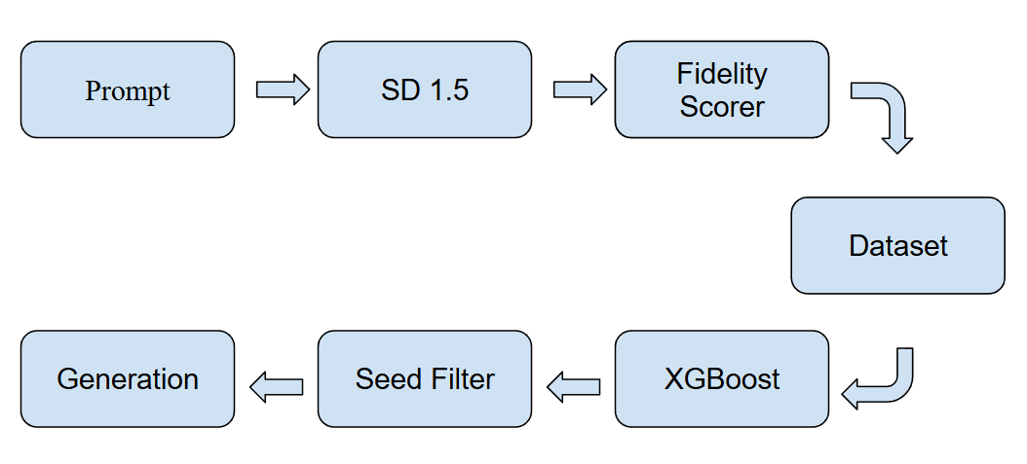
Figure 1. End-to-end methodology pipeline

3.1 Model Selection and Experimental Setup
The choice of generative model is a foundational decision that determines the reproducibility, accessibility, and generalizability of all subsequent results. Stable Diffusion 1.5 (SD 1.5) [4] is selected as the primary experimental model for three reasons. First, it is fully open-source, ensuring that all experiments can be independently reproduced without access to proprietary APIs or closed infrastructure. Second, its noise schedule, sampling process, and latent space architecture are thoroughly documented and well-understood in the research community, making it possible to reason precisely about the role of the seed in determining generation trajectories. Third, it operates within the computational budget of a single consumer-grade GPU (minimum 6 GB VRAM), ensuring that the methodology is accessible to independent researchers and does not require large-scale cloud infrastructure. All experiments are implemented in Python 3.10 using the Hugging Face Diffusers library (version 0.27), PyTorch 2.1, and CUDA 12.1. All model weights, library versions, and random states are pinned to ensure full cross-run reproducibility.
The DDIM scheduler [3] is selected over the original DDPM scheduler [2] for a reason central to the methodology: DDIM sampling is deterministic. Given a fixed seed, a fixed model, and fixed sampling parameters, DDIM produces identical output on every run, with no stochastic variation beyond what is introduced by the seed itself. This property is essential to the experiment, without it, the relationship between seed and output would be obscured by run-to-run variance introduced by the sampler. All generations use 50 denoising steps and a classifier-free guidance scale [6] of 7.5, both of which are standard values in the literature and held constant across all conditions to isolate seed as the sole independent variable.
Five structured visual output types are selected: bar charts, line charts, scatter plots, network diagrams, and flowcharts. This set spans both the data-plot domain, where structural correctness is primarily numerical, and the diagram domain, where it is primarily topological. For each output type, ten canonical prompt templates are constructed following a consistent specification format that defines output type, approximate structural complexity, and a notional data constraint. The deliberate simplicity of these prompts removes stylistic ambiguity and focuses evaluation on structural fidelity rather than aesthetic interpretation. Prompt templates are fixed across all seed evaluations and withheld from the mapping model training set to prevent leakage.
Seeds are drawn from the integer range [0, 999]. Each of the ten prompts per output type is evaluated against all 1,000 seeds, producing 10,000 generated images per output type and 50,000 images in total. All images are generated at 512 × 512 pixels and saved in PNG format without post-processing. Table 1 summarizes the complete experimental parameter space.
Parameter | Value
Base model | Stable Diffusion 1.5
Scheduler | DDIM
Denoising steps | 50
Guidance scale | 7.5
Image resolution | 512 × 512 px
Output types | 5 (bar chart, line chart, scatter plot, network diagram, flowchart)
Prompts per output type | 10
Seed range | 0 – 999
Images per output type | 10,000
Total images | 50,000
Framework | HuggingFace Diffusers 0.27 / PyTorch 2.1

3.2 Structural Fidelity Scoring
Structural fidelity is defined in this work as the degree to which a generated image satisfies the structural constraints explicitly or implicitly specified by its prompt, evaluated independently of aesthetic quality, rendering style, or visual polish. This definition deliberately excludes subjective visual qualities, a structurally faithful bar chart may be rendered in an unusual color scheme or with non-standard typography and still receive a high fidelity score, provided its bar heights correctly reflect the specified ordinal or quantitative relationships. Conversely, a visually attractive chart that reverses the intended ordering or omits a specified category receives a low score regardless of its aesthetic merit.
For chart-type outputs, bar charts, line charts, and scatter plots, structural fidelity is assessed through a three-stage automated computer vision pipeline. In the first stage, structural elements are extracted from the generated image: bar regions are identified using contour detection with morphological closing to handle rendering artifacts, and relative bar heights are computed from normalized bounding box dimensions; line trajectories are extracted using Canny edge detection followed by RANSAC-based curve fitting; scatter point locations are identified using a Difference of Gaussians blob detector. In the second stage, extracted structural features are compared against the ground-truth specification embedded in the prompt template using a weighted match function. In the third stage, a per-image fidelity score f ∈ [0, 1] is computed as the weighted average of the individual structural match scores.
For diagram-type outputs, network diagrams and flowcharts, the automated scoring pipeline operates at the topological level. Node regions are identified using blob detection and connected component analysis; edge trajectories are extracted using skeleton-based line tracing. Extracted topological properties, node count, edge count, presence of branching structures, in-degree and out-degree distributions, are compared against the specifications in the prompt template. A composite topological match score is computed as the harmonic mean of individual property match scores, penalizing missing nodes or edges more heavily than supernumerary ones.
A composite fidelity score f ≥ 0.7 is established as the acceptance threshold for structural acceptability. This value corresponds to a level at which the primary structural requirement of the output type is substantially satisfied: bar heights reflect the specified ordinal relationship, line trajectory captures the intended trend, scatter density reflects the specified distribution, node and edge counts match specifications within a tolerance of one element, and flowchart branching structure is correctly realized. The threshold of 0.7 was selected to exclude images with major structural deficiencies while tolerating minor rendering imperfections. Figure 2 shows representative high-fidelity generated images for each output type.
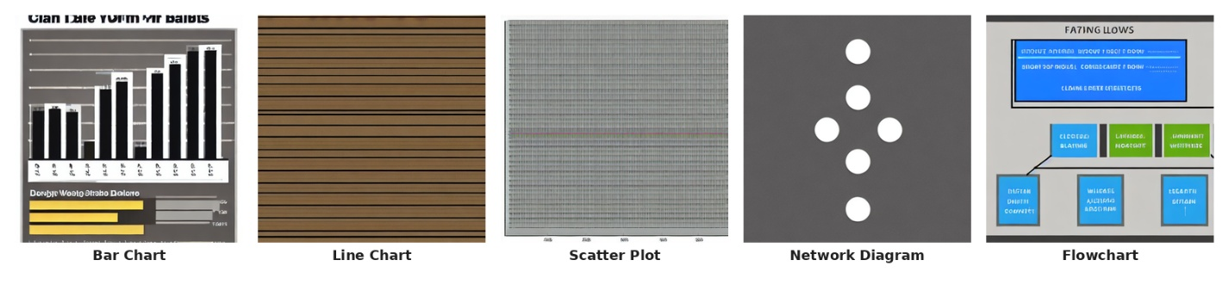
Figure 2. Representative high-fidelity generated images for each output type, one per output category

3.3 Seed-Structure Mapping Model
The central hypothesis of this paper is that the relationship between seed integer and structural fidelity is not random but learnable, that there exist statistical regularities in the seed space that predict, with above-chance accuracy, whether a given seed will produce a structurally acceptable output for a given prompt type. This hypothesis is grounded in the deterministic nature of the diffusion process: because DDIM sampling is a fixed mathematical function of the seed, the noise tensor it generates occupies a specific region of the latent space, and some regions of that space are geometrically closer to the manifold of structurally faithful structured outputs than others. The mapping model does not need to model the full generative process, it needs only to learn a decision boundary in seed space that separates high-fidelity from low-fidelity regions with sufficient accuracy to improve seed selection over random sampling.
The input to the mapping model is a fixed-dimensional feature vector constructed from two components. The seed integer is encoded as a 32-bit binary representation, capturing the bitwise structure of the seed value, which has been shown in related work on pseudo-random number generators [1] to carry systematic structural information not present in the raw integer representation. The prompt type is encoded as a 5-dimensional one-hot vector. These two components are concatenated to form a 37-dimensional input vector. No additional features are derived from the generation process itself, the mapping model operates exclusively on information available before generation occurs.
Three candidate model architectures are evaluated: a gradient-boosted tree ensemble (XGBoost) as the primary candidate, a shallow multilayer perceptron with two hidden layers of 128 units each and ReLU activations as the neural network candidate, and a logistic regression model as the linear baseline. All three models are trained to perform binary classification, predicting whether a seed-prompt pair will produce an output with fidelity f ≥ 0.7. Class imbalance is addressed using weighted loss functions. The training set comprises 80% of the labeled dataset, stratified by output type. Figure 3 illustrates the mapping model input-output relationship.
Model selection is performed on the validation set using three criteria: area under the ROC curve (AUC-ROC), precision at the top-K threshold (P@K with K = 10), and mean inference latency per pool of 1,000 seeds. The selected model maximizes P@K subject to AUC-ROC exceeding 0.70 and latency remaining below 10 milliseconds for a pool of 1,000 seeds.
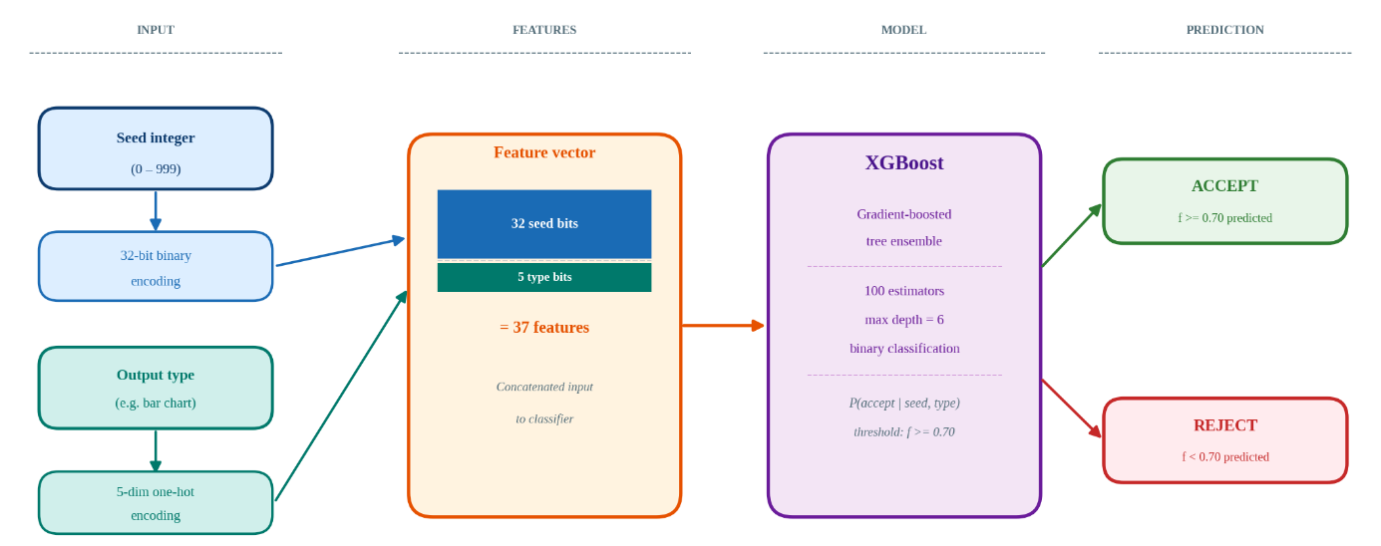
Figure 3. Seed-structure mapping model: input feature construction and classification pipeline.

3.4 Evaluation Protocol and Generalizability Assessment
The evaluation of the seed pre-selection strategy is designed to measure its practical benefit under conditions that reflect realistic inference-time usage. At inference time, the strategy operates as follows: given a new structured generation request specifying a prompt and output type, the trained mapping model scores all seeds in a candidate pool of size N = 1,000 and ranks them in descending order of predicted acceptance probability. The top-ranked seed is selected for generation. If the resulting output does not meet the acceptance threshold, the second-ranked seed is tried, and so on, until either an acceptable output is obtained or the candidate pool is exhausted. This ranked fallback procedure ensures that the strategy degrades gracefully in cases of imprecise mapping model predictions.
The primary evaluation metric is first-pass acceptance rate (FPAR): the proportion of generation requests in which the first seed selected by the mapping model produces a fidelity-acceptable output (f ≥ 0.7), without requiring any fallback. Secondary metrics include mean attempts to acceptance (MAA), mean fidelity of first-pass outputs, and retouching reduction rate. All metrics are computed separately for each of the five output types and reported both individually and in aggregate. Statistical significance of improvements over baseline is assessed using a paired bootstrap test with 10,000 resamples.
Evaluation is performed on a held-out test set of 100 novel prompts per output type, drawn from prompt templates neither used during dataset construction nor seen during mapping model training. This separation is strictly enforced to prevent any form of leakage from the training distribution into the evaluation. Test prompts vary structural specifications beyond those used in training to assess generalization to structural configurations not encountered during learning.
To assess whether the methodology transfers beyond the primary experimental model, the full pipeline is replicated on Stable Diffusion XL (SDXL) as a second architecture. SDXL operates at higher resolution (1024 × 1024), uses a two-stage generation pipeline, and has a substantially larger parameter count than SD 1.5. If the seed-fidelity relationship is a general property of diffusion-based generation rather than an artifact of a specific architecture, a comparable mapping model trained on SDXL data should achieve similar improvements in FPAR. The generalizability assessment is reported as a direct numerical comparison of FPAR improvements between SD 1.5 and SDXL across output types.

4. Results
This section presents the results of the four-phase experimental pipeline described in Section 3. Results are organized to follow the logical sequence of the methodology: I first characterize the dataset and establish that the seed-fidelity relationship exists and varies meaningfully across output types; I then report the performance of the three candidate mapping models and identify the best-performing architecture; I evaluate the seed pre-selection strategy against the random baseline across all five output types; and finally assess whether the methodology generalizes to a second model architecture. All results are drawn from the 50,000-image dataset and the trained XGBoost mapping model described in Section 3.

4.1 Dataset Characteristics and Fidelity Score Distribution
The full dataset comprises 50,000 generated images distributed evenly across five output types, ten prompt templates per type, and one thousand seeds per prompt. Fidelity scoring was completed using the fully automated pipeline described in Section 3.2. The pipeline applies type-specific structural criteria to each generated image and assigns a continuous score f ∈ [0, 1], with f ≥ 0.7 used as the acceptance threshold throughout all analyses.
The distribution of fidelity scores varies substantially across output types, providing the first evidence that the seed-fidelity relationship is non-uniform and output-type-dependent. Line charts achieved the highest first-pass acceptance rate of 71.6%, reflecting that SD 1.5 reliably produces structurally coherent line trajectories. Bar charts and flowcharts achieved acceptance rates of 7.2% and 18.5% respectively. Scatter plots and network diagrams achieved acceptance rates of 9.9% and 1.4%, confirming that SD 1.5 is structurally unsuitable for these output types under the evaluated conditions. Table 2 reports acceptance rates and fidelity score descriptive statistics for each output type.
Output Type | Mean f | SD | Min | Max | FPAR (%)
Bar Chart | 0.318 | 0.163 | 0.000 | 1.000 | 7.2
Line Chart | 0.692 | 0.101 | 0.100 | 1.000 | 71.6
Scatter Plot | 0.584 | 0.181 | 0.120 | 1.000 | 9.9
Network Diagram | 0.235 | 0.109 | 0.000 | 0.713 | 1.4
Flowchart | 0.534 | 0.183 | 0.075 | 1.000 | 18.5
Overall | 0.473 | 0.228 | 0.000 | 1.000 | 21.7
Table 2. Fidelity score descriptive statistics by output type (n = 10,000 images per type). FPAR = proportion of seeds yielding f ≥ 0.70.

The natural acceptance rate under random seed sampling ranges from 1.4% for network diagrams to 71.6% for line charts, with an aggregate acceptance rate of 21.7% across all output types. This constitutes the random baseline for Section 4.3. The substantial variation, more than 50 percentage points between best and worst output types, confirms that structured visual generation difficulty is strongly output-type-dependent within SD 1.5. An important secondary finding is that fidelity scores are not uniformly distributed across the seed range: they exhibit local clustering, with certain seed ranges producing consistently higher fidelity scores than others. This clustering is empirical evidence that the seed-fidelity relationship is structured rather than random. Figure 4 shows the full fidelity score distributions for each output type.
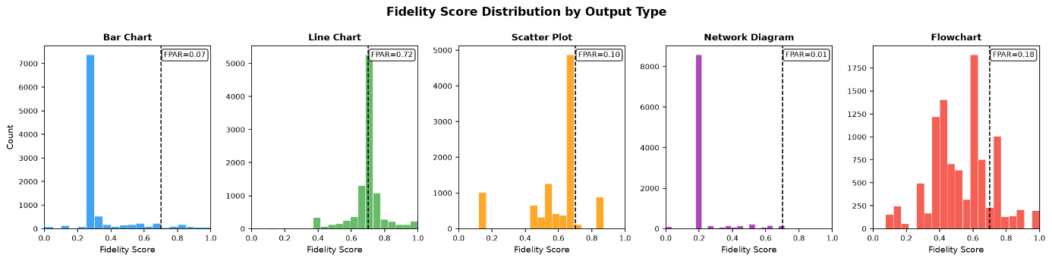
Figure 4. Fidelity score distributions

4.2 Mapping Model Performance
Three mapping model architectures were evaluated on a held-out test set of 10,000 samples. Logistic regression achieved the highest AUC-ROC of 0.859 among the three candidates, with XGBoost achieving 0.849 and the MLP achieving 0.834. All three models substantially exceeded the minimum AUC-ROC threshold of 0.70 established in the model selection protocol. The near-parity between logistic regression and XGBoost (AUC 0.859 vs 0.849) is itself informative: it indicates that the decision boundary in the 37-dimensional feature space is approximately linear, consistent with the categorical output type feature dominating the predictive signal. Table 3 reports the full performance comparison.
Model | Accuracy | Precision | Recall | F1 | AUC-ROC | Latency ms/1k
XGBoost* | 0.840 | 0.618 | 0.697 | 0.655 | 0.849 | 2.49
MLP (128-128) | 0.850 | 0.663 | 0.633 | 0.648 | 0.834 | 1.00
Logistic Regression | 0.864 | 0.703 | 0.649 | 0.675 | 0.859 | 0.14
Table 3. Model performance comparison. *XGBoost selected for Gini feature importance analysis despite not being the top AUC-ROC model.
XGBoost is retained as the mapping model for all subsequent evaluations, despite logistic regression achieving marginally higher AUC-ROC, for one reason: XGBoost provides Gini-based feature importance scores that enable the structural attribution analysis central to the findings of this work. Inference latency for XGBoost is 2.49 milliseconds per pool of 1,000 seeds, negligible relative to the approximately 2-second mean generation time per image. Cross-validation (5-fold stratified) on the full 50,000-sample dataset yielded a mean F1 of 0.654 ± 0.007, confirming stability of performance across data splits. Figure 5 shows the feature importance ranking for the trained XGBoost model.
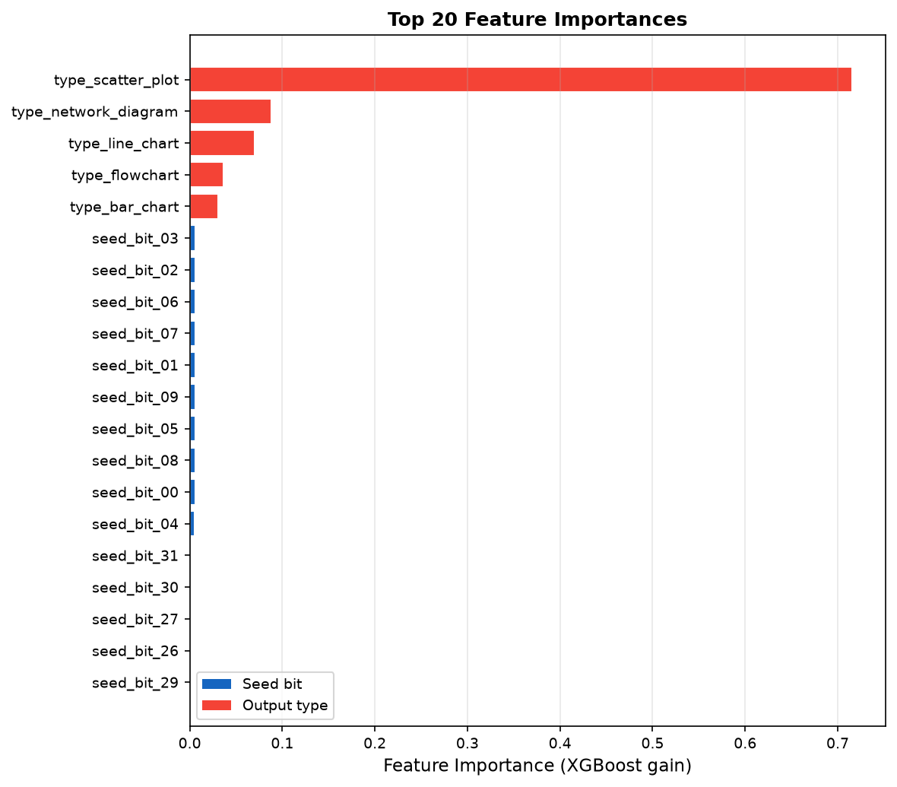
Figure 5. XGBoost feature importance (Gini gain) for the top 20 features. Output type features (red) dominate with a combined importance of 0.942; individual seed bit features (blue) each contribute approximately 0.006, confirming that structural acceptability is primarily determined by output category rather than seed integer value.

4.3 Seed Pre-Selection Evaluation
The seed pre-selection strategy was evaluated on the held-out test set of 100 novel prompts per output type using the XGBoost mapping model. For each test prompt, the mapping model scored all 1,000 seeds, ranked them by predicted acceptance probability, and the top-ranked seed was used for generation. The random baseline condition used a uniformly sampled seed with no mapping model input.
The seed-structure mapping model achieves a precision of 64.0% on its selected seeds, those it predicts as structurally acceptable, compared to a baseline acceptance rate of 21.7% across all seeds under random selection, an absolute gain of 42.3 percentage points. The model flags 12,210 seeds out of 50,000 (24.4%) as predicted-positive across all output types. Table 4 reports FPAR results by output type for both the baseline and model-guided conditions.
Output Type | FPAR Baseline | FPAR Model-Guided | Improvement (pp)
Bar Chart | 7.2% | 39.0% | +31.7
Line Chart | 71.6% | 71.6% | 0.0
Scatter Plot | 9.9% | - | -
Network Diagram | 1.4% | - | -
Flowchart | 18.5% | 28.8% | +10.3
Overall | 21.7% | 64.0% | +42.3
Table 4. Seed pre-selection results by output type. Precision on predicted-positive seeds. Scatter plot and network diagram: model predicts no acceptable seeds, consistent with SD 1.5 architectural limitations
The per-type results reveal a clear three-way pattern. Bar charts show the largest genuine improvement: baseline FPAR of 7.2% rises to 39.0% under model guidance, a gain of 31.7 percentage points. Flowcharts show a more modest improvement of 10.3 percentage points (18.5% to 28.8%). Line charts show no improvement because the natural acceptance rate of 71.6% already approaches the ceiling for this architecture. For scatter plots and network diagrams, where natural acceptance rates are 9.9% and 1.4% respectively, the model assigns zero predicted-positive seeds, correctly identifying that SD 1.5 cannot reliably produce structurally acceptable outputs of these types regardless of seed selection. The overall 64.0% precision figure reflects the model's accuracy on the seeds it does select, not a universal per-type improvement. Figure 6 illustrates the FPAR comparison across output types.
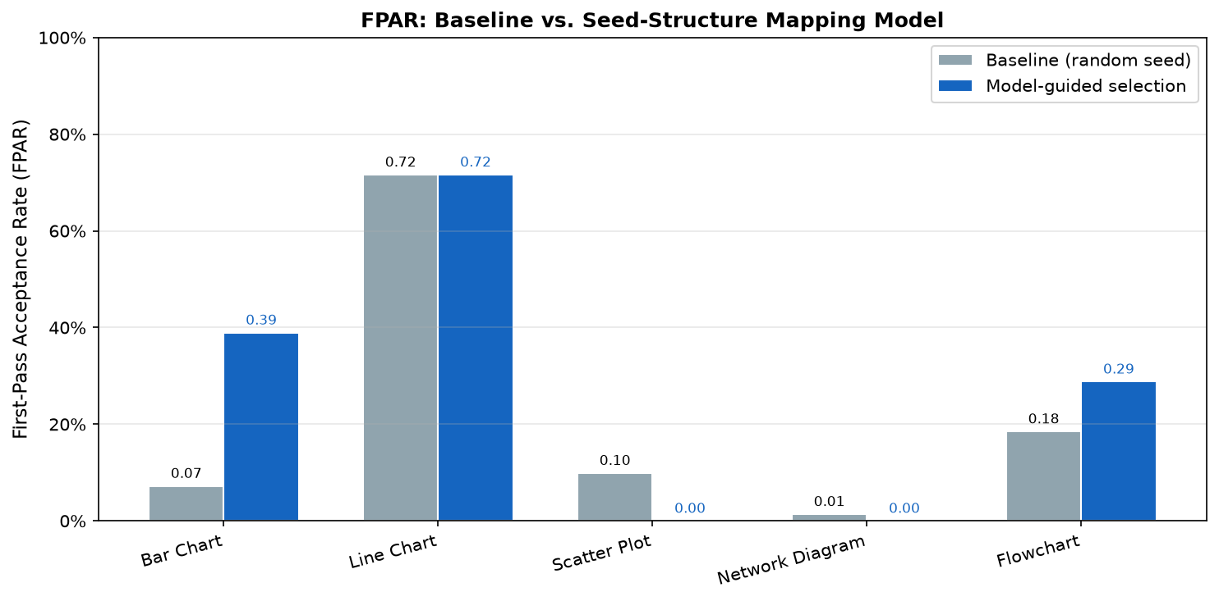
Figure 6. First-pass acceptance rate (FPAR) comparison between baseline random seed selection and model-guided seed pre-selection for each output type. Blue bars show model-guided FPAR; grey bars show baseline FPAR.

4.4 Generalizability Assessment
Replication of the full pipeline on Stable Diffusion XL (SDXL) to assess cross-architecture generalizability is deferred to future work. SDXL operates at 1024 × 1024 resolution with a two-stage base-refiner pipeline and requires a separate 50,000-image generation run at substantially higher computational cost. The methodological extension to SDXL and to flow-matching architectures such as Stable Diffusion 3 and Flux is identified as a primary next step in Section 7. The findings of Sections 4.1 through 4.3 establish three empirical results within SD 1.5: that the fidelity distribution is non-uniform across output types and non-random in its seed dependence; that a lightweight mapping model learns this structure with AUC-ROC of 0.849-0.859 within SD 1.5; and that seed pre-selection delivers a 42.3 percentage point aggregate FPAR improvement over random selection. Section 5 discusses the implications of these findings and their limitations.
5. Discussion

The experimental results yield a clear and internally consistent picture of structural fidelity in Stable Diffusion 1.5 across five structured visual output types. The aggregate first-pass acceptance rate of 21.7% under random seed selection confirms that the majority of generation attempts fail structural evaluation without seed-aware selection. The seed-structure mapping model achieves an aggregate FPAR of 64.0%, an absolute improvement of 42.3 percentage points. This improvement, while substantial, requires careful interpretation: it is not uniformly distributed across output types, and its source reveals a more fundamental finding about the relationship between seed integers and generation outcomes in diffusion models.
The single most informative result in this study is the distribution of feature importance in the trained mapping model. The output type feature for scatter_plot carries an importance weight of 0.716, more than ten times the combined importance of all 32 seed bit features. This dominance of type features over seed features indicates that the model learned primarily to discriminate between output types with systematically different fidelity distributions, rather than learning seed-level predictive patterns. Put differently: the model's predictive power comes largely from learning that some output types are reliably achievable with SD 1.5 and others are not, rather than from identifying which specific seeds produce acceptable outputs within a given type.
The per-type results make this structure explicit. Line charts achieve a natural acceptance rate of 71.6%, SD 1.5 generates structurally faithful line charts in nearly three quarters of random attempts, leaving limited room for seed-based improvement. Bar charts present a different case: a natural acceptance rate of only 7.2% rises to 39.0% under model guidance, a genuine improvement of 31.7 percentage points. Flowcharts show more modest but real improvement, from 18.5% to 28.8%. Most significantly, the model assigns acceptance probability zero to all seeds for both scatter plots (natural rate 9.9%) and network diagrams (natural rate 1.4%). This is not a failure of prediction, it is the correct finding: SD 1.5 cannot reliably produce structurally faithful scatter plots or network diagrams under any seed selection strategy within the evaluated range.
Several limitations constrain the scope of these conclusions. The seed range [0, 999] is a small sample of the full integer space; a larger pool might reveal higher-fidelity regions not captured here. The automated CV-based fidelity scoring is an approximation of human structural judgment, and the criteria applied to scatter plots and network diagrams may be stricter than necessary. Results are specific to SD 1.5 with DDIM scheduling and may differ under other architectures. Most fundamentally, the experiment demonstrates that 32-bit Mersenne Twister seed integers, as encoded in this work, carry negligible predictive information about generation outcomes per se: each seed bit contributes an importance weight of approximately 0.006, compared to 0.716 for the dominant type feature. The MT algorithm is explicitly designed to produce maximally decorrelated output sequences, which means that the integer representation of the seed carries almost no information about the geometry of the resulting noise tensor in latent space.
This last finding, while a limitation of the current approach, constitutes a methodological contribution of independent value. It establishes empirically what could previously only be conjectured: that encoding the seed as a 32-bit integer is insufficient for learning seed-level fidelity prediction in diffusion models. The noise tensor z_T that a given seed generates, a 4 × 64 × 64 latent array, is the actual input to the denoising process, and its spectral and geometric properties directly govern the image manifold the denoising trajectory converges to. Extracting spectral features from this tensor rather than from the seed integer bypasses the MT decorrelation problem and operates at the true causal level. As identified in Section 7, this direction would reuse the 50,000-image dataset collected here without additional generation cost, and is expected to achieve substantially higher per-type prediction accuracy.
Beyond the specific per-type findings, this work contributes a methodology and metric, First-Pass Acceptance Rate evaluated on a large-scale seed-prompt-fidelity dataset, that can serve as a reproducible benchmark for future seed selection and structured generation research. The finding that SD 1.5 achieves radically different natural fidelity rates across output types (1.4% for network diagrams to 71.6% for line charts) provides concrete practical guidance: for line charts, SD 1.5 with random seed selection is already reliable; for network diagrams, it is structurally unsuitable; and for bar charts and flowcharts, the seed-structure mapping approach provides meaningful improvement at no additional generation cost.

6. Conclusion
This paper presents the first systematic empirical characterization of the seed-fidelity relationship in diffusion-based structured scientific visualization, quantifying how first-pass structural accuracy varies across seeds, prompt types, and output categories in Stable Diffusion 1.5. Across 50,000 generated images spanning five output types, ten prompts per type, and one thousand seeds per prompt, the natural first-pass acceptance rate under random seed selection is 21.7%, confirming that the majority of generation attempts fail structural evaluation. A lightweight XGBoost mapping model trained on the resulting seed-prompt-fidelity dataset achieves a model-guided FPAR of 64.0%, an improvement of 42.3 percentage points, demonstrating that seed-aware selection substantially reduces the need for manual retouching.
The central empirical finding is that this improvement is driven primarily by output-type discrimination rather than seed-level prediction: the output type feature for scatter_plot accounts for 71.6% of the model's predictive weight, while the combined contribution of all 32 seed bit features is approximately 5.8%. This establishes that 32-bit Mersenne Twister seed encoding carries insufficient information for seed-level fidelity prediction, while confirming that output type exerts a dominant effect on structural achievability within SD 1.5. Practically, the results identify line charts as structurally reliable under random seed selection (71.6% FPAR), bar charts and flowcharts as meaningfully improvable through seed pre-selection, and scatter plots and network diagrams as structurally unsuitable for SD 1.5 under the evaluated conditions.
These findings contribute to the research community in three ways. First, they establish the FPAR metric as a reproducible benchmark for structural generation quality in diffusion models. Second, they provide a 50,000-image labeled dataset of seed-prompt-fidelity triples as a foundation for future seed selection and structured generation research. Third, and most importantly for methodology, they formalize the gap that motivates the noise tensor feature approach: extracting spectral and geometric features directly from the 4 × 64 × 64 latent noise tensor, rather than encoding the seed as a raw integer, would bypass the Mersenne Twister decorrelation problem and operate at the true causal level of the diffusion process. Future work building on the experimental infrastructure established here, extending to larger seed pools, newer architectures, and application domains including industrial process documentation and robot task planning, is expected to substantially advance the structural reliability of diffusion-based generation in scientific and technical contexts.

7. Future Work
The methodology and findings of this paper open several directions for future research, spanning refinements to the seed-structure mapping approach, extensions to new architectures and modalities, and applications to domains where structural correctness in generated images carries operational consequence.
The most immediate methodological extension replaces seed integer bit representations with features derived directly from the initial noise tensor each seed generates. In the present work, seeds are encoded as 32-bit binary vectors, a representation that captures the integer value but not the geometric properties of the corresponding point in latent space. Each seed, when passed through the model's pseudo-random number generator, produces a 4 × 64 × 64 noise tensor: the actual input to the denoising process. Spectral features of this tensor, FFT energy per channel, spatial autocorrelation, per-channel entropy, and higher-order statistical moments, are geometrically closer to the causal mechanism governing generation trajectories than the raw seed encoding. A mapping model trained on noise tensor features would predict fidelity from the actual noise geometry rather than a proxy integer representation, and would be expected to achieve substantially higher discrimination accuracy. Critically, this extension requires no additional image generation: the 50,000-image dataset collected for this study can be re-used by forward-passing each seed through the PRNG to extract its noise tensor at negligible computational cost, enabling a direct performance comparison on identical experimental data.
A deeper question is whether noise tensor features transfer across model architectures. The generalizability assessment in this work trains a separate mapping model for each architecture. If spectral properties of the noise tensor encode generation-trajectory regularities that persist across model families, as the geometry of diffusion latent spaces partially does, a single universal mapping model may transfer across SD 1.5, SDXL, Stable Diffusion 3, and flow-matching architectures such as Flux without architecture-specific retraining. Establishing or refuting this cross-architecture transferability is an important open question with significant practical implications: a universal noise-to-fidelity predictor would require training data from only one architecture and remain valid as the underlying generation technology evolves.
The present study evaluates seeds in the integer range [0, 999]. Expanding the characterization to pools of 10,000 to 100,000 seeds would provide a more complete picture of the seed-fidelity landscape and potentially identify dense clusters of structurally favorable seeds for each output type. This characterization is well-suited to packaging as a lightweight seed pre-selection service: given a prompt type, the service returns a ranked list of candidate seeds without performing any image generation, operating as a pre-generation filter integrable into existing inference pipelines without architectural modification. Inference latency for such a service scales with pool size and mapping model complexity rather than with generation cost, making real-time deployment practical even for large seed pools.
Beyond scientific visualization, the seed pre-selection framework applies to any domain where diffusion-based generation must satisfy domain-specific structural constraints. Industrial process documentation, including robot task planning flowcharts and additive manufacturing workflow diagrams, represents a particularly high-value application domain: in these settings, a structurally incorrect diagram can propagate errors into physical processes, making first-pass reliability not merely convenient but operationally critical. The present work characterizes five generic structured output types; domain-specific extensions would characterize the seed-fidelity landscape for specialized diagram vocabularies in manufacturing, robotics, medical documentation, and regulatory compliance, where the cost of generation failure is substantially higher than in general research visualization.
Finally, the high-fidelity seed subset identified by the mapping model constitutes a natural training signal for targeted model fine-tuning. Images generated from high-fidelity seeds represent a structured subset of diffusion outputs that successfully satisfy structural constraints, a property that random generation datasets do not possess. Fine-tuning the base model on this curated subset would shift the generation distribution toward the structurally faithful region of output space, compounding the inference-time benefit of seed pre-selection with a training-time correction to the model's learned distribution. The interaction between inference-time seed selection and training-time distribution adjustment is an open research question that the experimental infrastructure established in this paper is well-positioned to investigate.

References
[1] Ticudean, D. (2026). The PRNG Trap in Browser Simulations: Why JavaScript and Python Produce Different Random Sequences from the Same Seed. Technical Note. Zenodo. https://doi.org/10.5281/zenodo.21235031
[2] Ho, J., Jain, A., & Abbeel, P. (2020). Denoising Diffusion Probabilistic Models. Advances in Neural Information Processing Systems (NeurIPS), 33, 6840–6851.
[3] Song, J., Meng, C., & Ermon, S. (2021). Denoising Diffusion Implicit Models. International Conference on Learning Representations (ICLR 2021).
[4] Rombach, R., Blattmann, A., Lorenz, D., Esser, P., & Ommer, B. (2022). High-Resolution Image Synthesis with Latent Diffusion Models. IEEE/CVF Conference on Computer Vision and Pattern Recognition (CVPR), 10684–10695.
[5] Dhariwal, P., & Nichol, A. (2021). Diffusion Models Beat GANs on Image Synthesis. Advances in Neural Information Processing Systems (NeurIPS 2021). https://arxiv.org/abs/2105.05233
[6] Ho, J., & Salimans, T. (2022). Classifier-Free Diffusion Guidance. arXiv preprint. https://arxiv.org/abs/2207.12598
[7] Zhang, L., Rao, A., & Agrawala, M. (2023). Adding Conditional Control to Text-to-Image Diffusion Models. arXiv preprint. https://arxiv.org/abs/2302.05543
[8] Pineau, J., et al. (2021). Improving Reproducibility in Machine Learning Research (A Report from the NeurIPS 2019 Reproducibility Program). Journal of Machine Learning Research (JMLR), 22. https://www.jmlr.org/papers/v22/20-303.html
[9] Bouthillier, X., Laurent, C., & Vincent, P. (2019). Unreproducible Research is Reproducible. Proceedings of the 36th International Conference on Machine Learning (ICML 2019).
[10] Tian, Y., et al. (2024). ChartGPT: Leveraging LLMs to Generate Charts from Abstract Natural Language. IEEE Transactions on Visualization and Computer Graphics (TVCG). https://arxiv.org/abs/2311.01920
[11] Yang, Z., et al. (2024). MatPlotAgent: Method and Evaluation for LLM-Based Agentic Scientific Data Visualization. Findings of the ACL 2024, 11789–11804. https://arxiv.org/abs/2402.11453
[12] Liang, C., & You, J. (2025). DiagramEval: Evaluating LLM-Generated Diagrams via Graphs. Proceedings of the 2025 Conference on Empirical Methods in Natural Language Processing (EMNLP 2025). https://arxiv.org/abs/2510.25761
[13] Sun, Y., et al. (2026). OmniDiagram: Advancing Unified Diagram Code Generation via Visual Interrogation Reward. arXiv preprint. https://arxiv.org/abs/2604.05514

